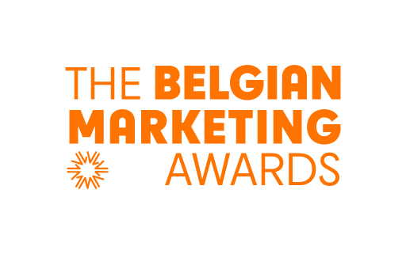

CONFIRMATION FORM

Marketing Company of the year

Congratulations, your company has been nominated for this award.
PLEASE SEND YOUR CONFIRMATION FORM TO nathalie.prieto@marketing.be before July 31 2021.

With this award we want to foster best, meaningful marketing practices - based on a strong customer centric strategy - which deliver superior business results.
The Corona crisis has obviously had a major impact on many if not all aspects of our way of doing business.
This award is in no way an award intended for the company which best coped with this impact or best reacted or best grabbed new opportunities arising from this crisis.
However, this award is an award for the company that best managed to overcome these unexpected challenges, showed thought leadership and hence succeeded to sail through rough seas while staying true to its strategy, delivering superior business results and acting in coherence with the Meaningful Marketing framework.

Your coordinates:
First name:
Name:
E-mail:
Phone number:
Company:
Please validate your case:

Step 1: General selection criteria: The case concerns the performance of brand, a company or organization, not a campaign.
- The case is about a brand, a company or organization that is active on the Belgian market and makes strategic marketing decisions in Belgium.
- The brand, company or organization can demonstrate a customer-centric corporate culture / a customer-driven decision making policy.
- The brand, company or organization demonstrates innovation & leadership in the field of marketing, inspired by BAM's meaningful marketing framework.
- The brand, company or organization can present successful (business) results and it is likely that the organization is and will remain successful in the future
- In addition to the successful business results, the brand, company or business can demonstrate a positive social impact.
- The brand, company or organization has found a distinctive/unique way to fulfill a customer need with its (portfolio of) products/services.
- The way in which the relationship with the target group is initiated or maintained, is or remains innovative (innovative)

Hereby, I confirm to comply with the general selection criteria of Marketing Company of the year:
- Yes
- No

Step 2: The specific criteria for Marketing Company of the year:
- The brand, company or organization exists/is active on the Belgian market for more than 5 years.
- Within the company/organization, marketing has for years played a clear, leading role in determining vision, purpose, strategy and business operations, i.e. customer-centric entrepreneurship has been successfully integrated into strategic business operations.
- The brand, the company, the organization has an impeccable reputation
- The brand, the company, the organization has implemented a successful customer-centric innovation/transformation over the past 3 years.
- In recent years the marketing team has built bridges between value chain, internal functional divisions, consumers/customers and stakeholders/environment.
- The case concerns an organization in the Adulthood phase of the lifecycle

Hereby, I confirm the brand, company, organization contributes/is willing to contribute to the promotion of the marketing profession by actively promoting its marketing vision and sharing its knowledge (with the aim of spreading vison and knowledge to the wider audience).
- Yes
- No

Signature:

PLEASE SEND YOUR CONFIRMATION FORM (2 pages) TO nathalie.prieto@marketing.be as soon as possible but not later than July 31 2021.

Case Entry FORM For

Marketing Company of the year

The CASE ENTRY FORM is pre-formatted document, which you should use for submitting your case. It contains 6 sections with a limited number of lines for each of the sections.

The deadline for your CASE ENTRY is September 9th 2021. Please send your Case entry Form in PDF to nathalie.prieto@marketing.be.

Your coordinates:
First name:
Name:
E-mail:
Phone number:
Company:
The Title of your case:

SECTION 1 (10 points):

Introduction: The context & Challenge & Opportunities and Threats

Introduce the company: What are the activities? In which category/categories your company is operating? Who are your main competitors? Etc…:

(max. 10 lines)

What is the context? What is the Issue/the challenge? What are the risks and opportunities?

(max. 20 lines)

SECTION 2 (10 points):

Business Strategy

What is the business strategy? What does your company tries to achieve? How do you measure business success? What are the KPI’s?

(max. 20 lines)

SECTION 3 (15 points):
Value proposition

From a customer centric perspective: describe the customer centric value proposition? What made this proposition unique, different from your competitors, outstanding?

(max 20 lines)

SECTION 4 (15 points):
Marketing Strategy
What is the marketing strategy? What kind of customers is your company targeting? How does your company build relationships with clients? How do you measure success? What are the marketing KPI’s ?

(max 20 lines)

SECTION 5 (20 points):
Results
Marketing results & Business results

(max 30 lines)

SECTION 6 (20 points):
Thought leadership?
Referring to the Corona Crisis, to what extend was your strategy totally/partly/rather not resilient to the impact of the crisis? Why (not)?

(max 20 lines)

Referring to the Meaningful Marketing framework (see here), which dimensions can be considered as the drivers of your (future) success? Why? And which of the 6 dimensions are less relevant? Why?

(max 20 lines)

What can the marketing community learn from your case? What are the best practices to share and what can we learn from your failures?

(max 30 lines)

Thank you for your participation
Send this document in PDF to nathalie.prieto@marketing.be before September 9 2021
The selection Committee will announce the finalists by October 04 2021.
Finalists will present their case to the Jury on October 25 2021

Need more information?
www.belgianmarketingawards.be
Email : nathalie.prieto@marketing.be

